The application I have chosen to redesign in XR is TikTok, under the category of Social Connection. Users would be able to learn and film TikTok dances of themselves as an avatar in the VR environment.

Three tasks and goals that the users would perform with this XR app are:
1. Apply Special Effects: Users interact with a makeup station table to select, preview and adjust an effect by repositioning or resizing it through gestures, then applying the effect. Effects can be 2D on their avatar, or 3D in the spatial environment
2. Learn TikTok Dances: Interacting with the dance mirror enters ‘Learn a Dance’ mode. The original dance video plays on the left, and the user's avatar shows on the mirror on the right. Targets/bubbles guide the user to move their hands and feet, and they have to hit the targets correctly to master the dance.
3. Take Photos/Film Videos: Users pick up a camera to take a photo or video of their avatar in the VR environment, and are able to switch between modes through gestures. A tripod allows for a ‘hands-free’ mode, supported by Meta Quest native photo/video taking capabilities

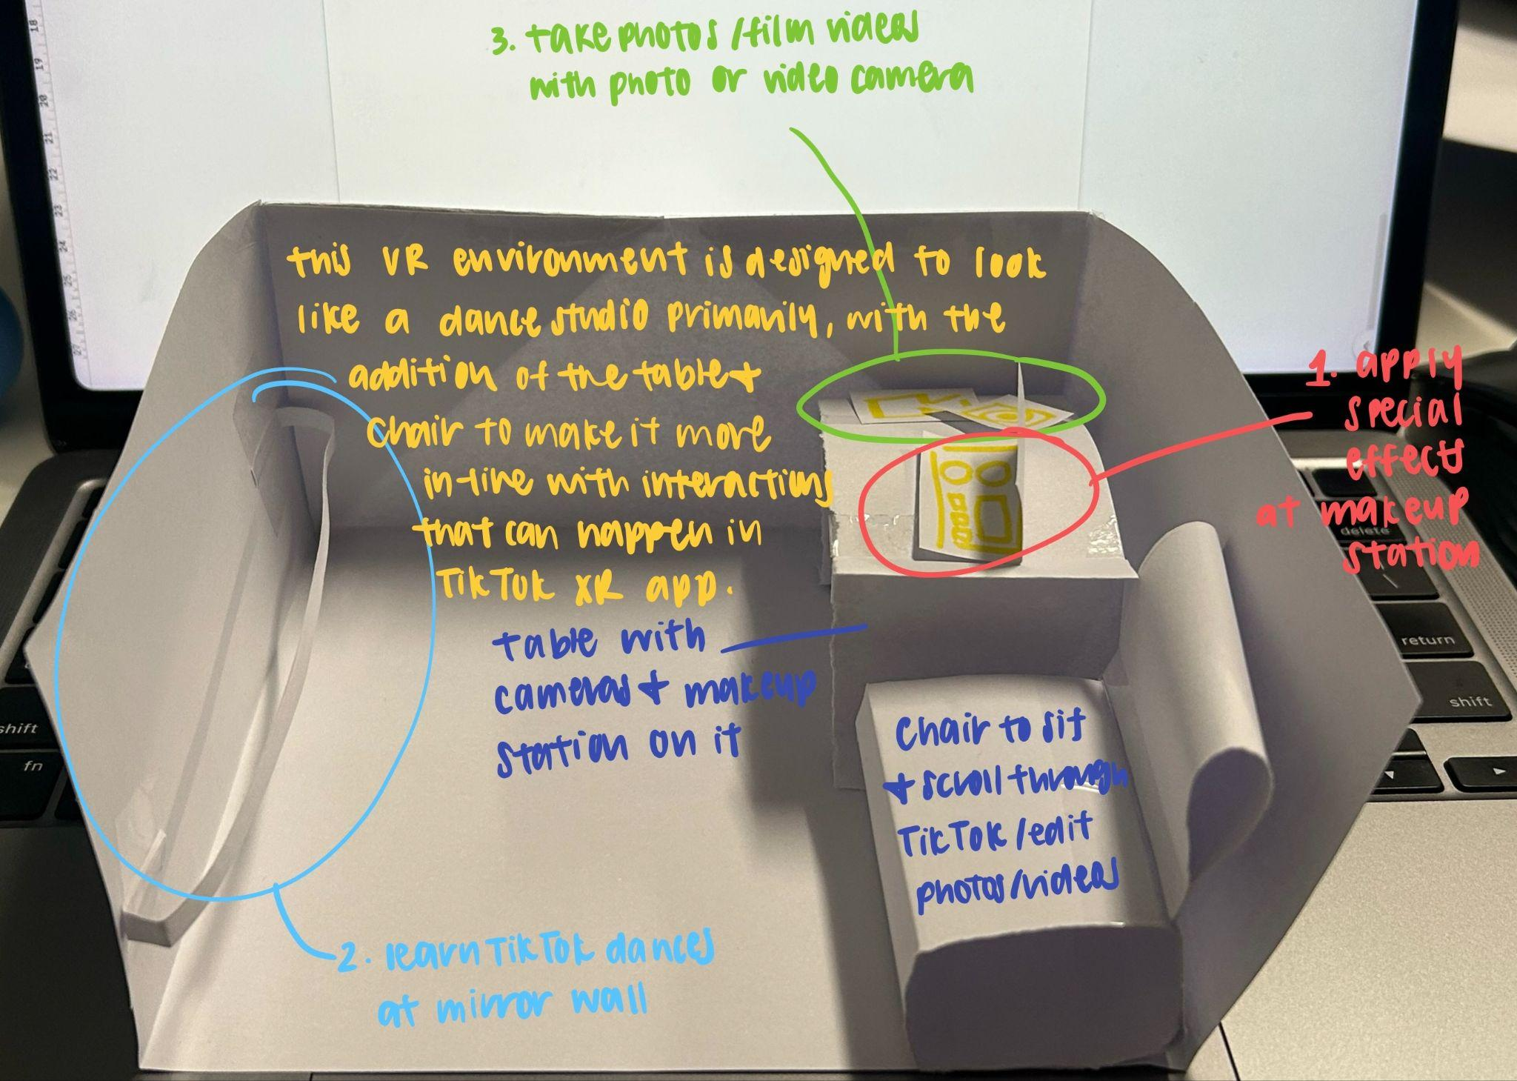
Image #1: Low-Fidelity Paper Prototype
Based on the initial three tasks I wanted users to complete in the XR app, I created a low-fidelity paper prototype of the VR environment. This was in order to envision the entire environment, as well as see how tasks would be performed in the environment, and get feedback from my classmates. This paper prototype can be seen in Image #1, where I designed the XR app to be like a dance studio, with the addition of a table and chair to be in line with the TikTok app functionalities as well as the tasks I wanted users to be able to complete. Additional images of the paper prototype can be seen in my GitHub ‘Mock Up Paper XR UI’ folder.

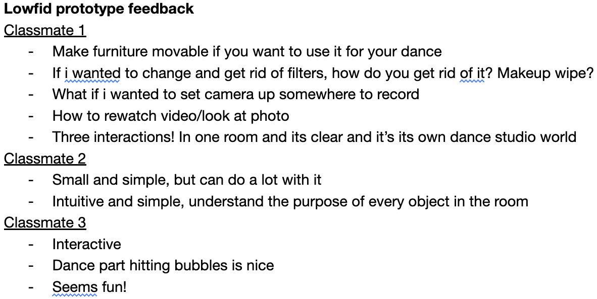
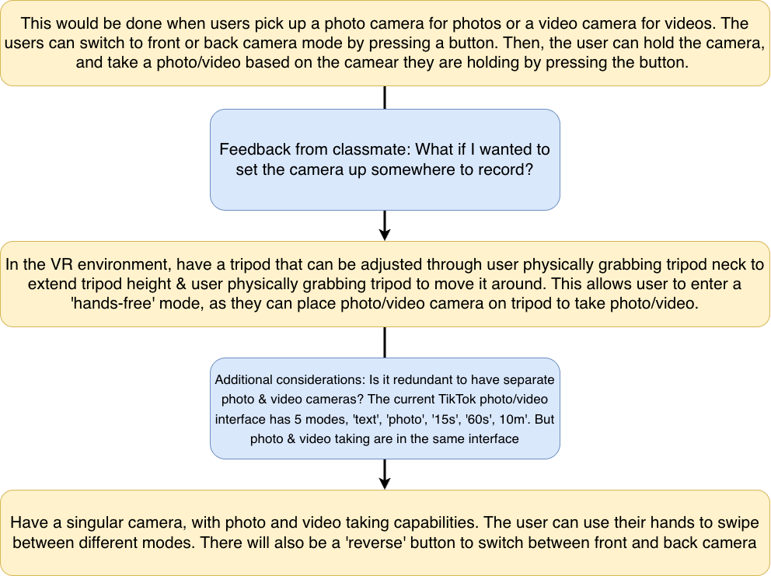
Image #2: Low-Fidelity Feedback After creating the low-fidelity paper prototype, I received feedback from three classmates, shown in Image #2. This feedback offered ideas I had not previously considered, and was used when developing the initial ideas I had for my tasks. As seen in Image #3, I went through two rounds of refinement for Task: 2 Photo/Video Taking. I had the first initial idea of having photo and video cameras that users would hold to take content. I then received feedback from a classmate saying “what if I wanted to set the camera up
Image #3: Task Iteration: Take Photos/Videos somewhere to record?” From there, I decided to add a camera tripod that users can reposition and adjust as desired, to enter a “hands-free” mode. I then looked at the existing TikTok camera interface, and noticed that photo and video taking capabilities were in the same interface, and there were different modes of video taking based on duration. From there, I decided to improve the camera interface by combining photo and video modes, and adding a ‘reverse’ button to flip the camera. My initial ideas and task iteration can be seen in my GitHub ‘Initial Idea Ideation.pdf’.

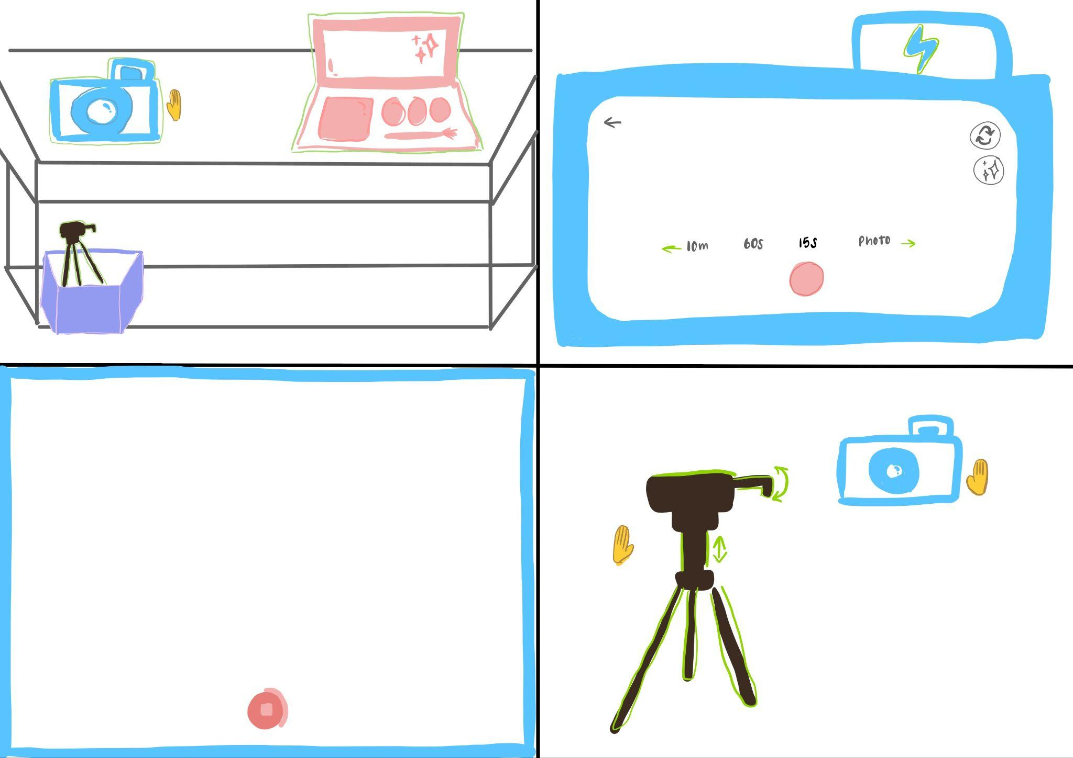
Images #4-5: Take Photos/Film Videos Storyboard; Take Photos/Film Videos Storyboard Annotated
The concept for this app in XR is a simple dance studio with a movable table and chair. Since the three tasks revolve around taking dance videos, the environment complements these tasks: One side has a table with a camera, tripod, and makeup filter station, fulfilling Task 1: Apply Special Effects and Task 3: Take Photos/Film Videos, while the other side has a dance mirror, fulfilling Task 2: Learn TikTok Dances. The simplicity of the dance studio mimicking a real one, along with realistic item placement, enhance realisticness and in turn user immersiveness in the XR app.
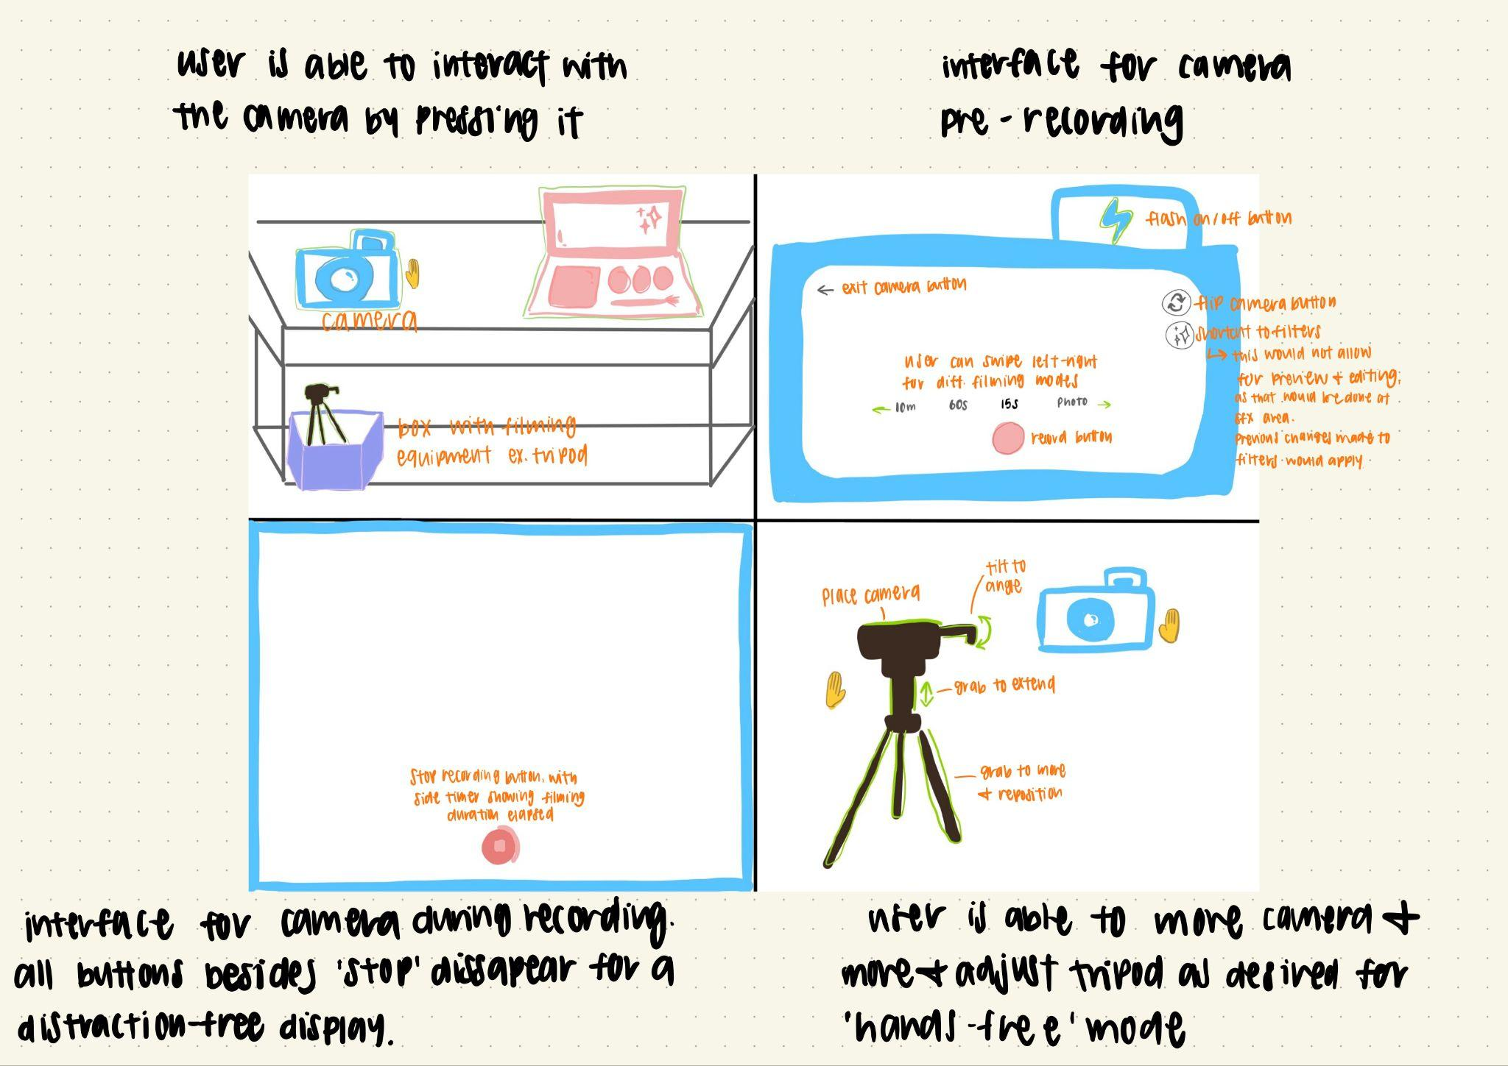
Image #4 shows the storyboard process for Task 3. The first sketch on the storyboard shows a table with a camera and a tripod in a box below. Objects with a purpose that can be interacted with have a green outline. Users grab the camera to open the camera interface relying on prior knowledge that cameras afford picking up and button pressing. The second sketch shows the pre-recording interface, styled similarly to TikTok’s to leverage users' existing mental models. Here, buttons allow pressing (exit, flash, reverse camera, filters, record), while recording modes afford swiping to switch, mirroring TikTok’s camera interface interactions. The third sketch shows an active recording: all buttons except record are removed so the user can focus on screen recording. A colored border signals filming mode, and the record button turns dark red with a timer around its circumference, again drawing from TikTok’s interface. The fourth sketch shows the user moving the camera and the tripod, one in each hand. Since the tripod has many interactable areas (ex. Resizing, repositioning), arrow buttons were added for intuitiveness. Annotations for this storyboard are in Image #5. Storyboards and annotations for Task 1 and Task 2 can be seen in my GitHub “XR App Storyboard” folder.

Below is an initial testing plan for my XR concept, for the three main tasks users need to complete:
Specific interactions and features to test:
- Whether users can accurately hit hand and foot targets in time with the reference video’s choreography
- Whether the ‘Learn to Dance’ side by side layout of reference video and avatar mirror help users compare and self-correct their movement
- Whether the gesture based controls at the makeup station and the camera/tripod are discoverable without instruction
Assumptions:
- Users can correctly interpret the targets as cues for where and when to move their hands and feet
- Comparing their avatar in the mirror against the original video in real time help users notice and correct mistakes
- Successfully hitting targets corresponds to genuinely learning the choreography, not just tapping target on rhythm
- TikTok derived interface conventions transfer intuitively to the VR gesture controls
- Users have prior knowledge on using a camera, tripod, and filters
What I need to know & data to be collected:
- Target hit accuracy: Percentage of hand/foot targets hit correctly per attempt
- Time taken to complete a full ‘Learn a Dance’ sequence, and whether accuracy improves across repeated attempts
- Task completion and error rate for the camera/tripod (reposition, resize, mode switching), and makeup station (select, preview, apply effect) gesture interactions
- A 1-5 ease of use rating for the dance mirror experience and for the gesture controls
- Short post-task interviews asking whether the targets and mirror comparison felt clear, and whether participants felt they had actually learned the dance versus just hitting the targets.

